**Module 1 QUIZ**

Introduction to MiniBridge

|  |  |  |  |
| --- | --- | --- | --- |
| **1.** | What is the rank of high cards in each suit? |  | |
| **2.** | What are the high card points for the four top honours? |  | |
| **3.** | In MiniBridge, who becomes the Declarer choosing the contract? |  | |
| **4.** | What do you need to bid game? |  | |
| **5.** | What are the game contracts? |  | |
| **6.** | What is a trick? |  | |
| **7.** | What do you need to choose a trump suit? |  | |
| **8.** | When do you bid no trumps? |  | |
| **9.** | What is the minimum number of tricks you need to make a contract? | |  |

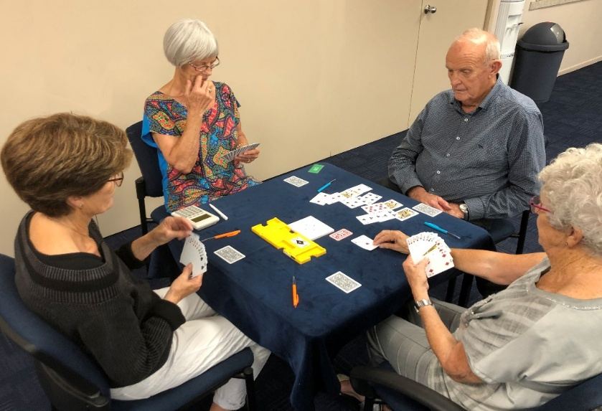

**S**

**W**

**N**

**E**

**In the photo above:**

|  |  |  |  |
| --- | --- | --- | --- |
| **10.** | Who is the dummy? |  | |
| **11.** | Who is the declarer? |  | |
| **12.** | Who made the opening lead? |  | |
| **13.** | North won the 1st trick with the ♠A, who leads to the next trick? |  | |
| **14.** | Opening lead vs 4♠, what do you lead from ♠A52 ♥532 **♦**KQJ9 ♣J83? | |  |
| **15.** | Opening lead vs 3NT, what do you lead from ♠J10972 ♥532 **♦**A9 ♣J83? | |  |

**Module 1 Quiz - Model Answers**

|  |  |  |  |
| --- | --- | --- | --- |
| **1.** | What is the rank of high cards in each suit? | **AKQJ1098765432** | |
| **2.** | What are the high card points for the four top honours? | **A=4, K=3, Q=2, J=1** | |
| **3.** | In MiniBridge, who becomes the Declarer choosing the contract? | **Whoever has the most HCP from side with most HCP** | |
| **4.** | What do you need to bid game? | **25+ HCP (High Card Points)** | |
| **5.** | What are the game contracts? | **3NT 4**♥ **4**♠ **5**♣ **5♦** | |
| **6.** | What is a trick? | **Collection of 4 cards, one from each player** | |
| **7.** | What do you need to choose a trump suit? | **A fit of at least 8+ cards** | |
| **8.** | When do you bid no trumps? | **When you don’t have a fit in a suit** | |
| **9.** | What is the minimum number of tricks you need to make a contract? | | **7 tricks** |



**S**

**W**

**N**

**E**

**In the photo above:**

|  |  |  |
| --- | --- | --- |
| **10.** | Who is the dummy? | **West** |
| **11.** | Who is the declarer? | **East** |
| **12.** | Who made the opening lead? | **South** |
| **13.** | North won the 1st trick with the ♠A, who leads to the next trick? | **North** |
| **14.** | Opening lead vs 4♠, what do you lead from ♠A52 ♥532 **♦**KQJ9 ♣J83? | **♦K** |
| **15.** | Opening lead vs 3NT, what do you lead from ♠J10972 ♥532 **♦**A9 ♣J83? | **♠J** |